|  |  |  |  |  |  |
| --- | --- | --- | --- | --- | --- |
| **Cuartil 50** | **Cuartil 50** | **ETH_Covertree (Mapa)** | **Fuera de Áreas protegidas** | **En RUNAP** | **En Resguardos** |
| km2 | 58175.19 | 31722.01 | 24699.93 | 5841.14 | 1180.95 |
| Porcentaje |  | 55% | 78% | 18% | 4% |

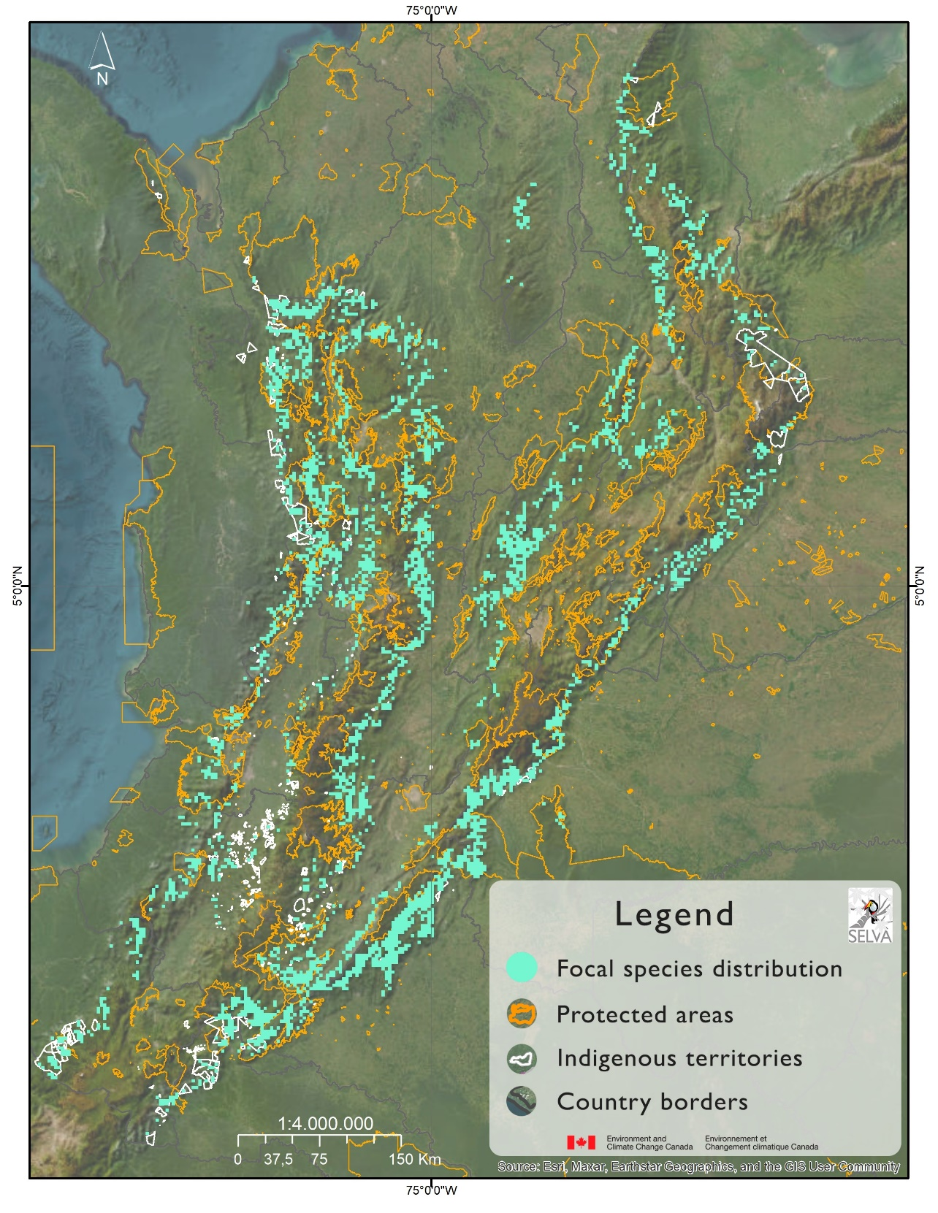

|  |  |  |  |  |  |
| --- | --- | --- | --- | --- | --- |
| **Cuartil 75** | **Cuartil 75** | **ETH_Covertree**  **(Mapa)** | **Fuera de Áreas protegidas** | **En RUNAP** | **En Resguardos** |
| km2 | 28460.79 | 14207.57 | 11754.84 | 2389.14 | 63.59 |
| Porcentaje |  | 50% | 82.7% | 16.8% | 0.4% |

